Reunion 2017
England Air Force Base

401st EAFB

Who: 401st EAFB troops
and their guests

When: Friday October 6 - 8, 2017
1230 Hrs. – Until ?????

Where: Comfort Suites
6015 Old Boyce Road
Alexandria, Louisiana 71303
(318) 445-9800
Reservation Group Name:
401st EAFB Reunion
http://www.comfortsuites.com/hotel-alexandria-louisiana-LA166?hotel=LA166

Lunch: Friday October 6, 2017
1230 – Until ?????

WE LOOK FORWARD TO SEEING YOU

England Air Force Base
401st EAFB

****Friday********
1200 - 1230 - Meet on base at the Alexandria Airport Board Room
(3rd Floor NW corner – Observation Deck)
1611 Arnold Drive - park in airport parking
1230 - 1400 - Lunch in the Alexandria Airport Board Room
1400 - 1600 - Time to discover the base
1600 - 1700 - England Authority, David Broussard sharing the Air Park _ vision (where the base was in 1992, where it is now and _ where it is going) – Alexandria Airport Board Room
1700 - 1900 - Welcome Reception – Alexandria Airport Board Room

Anyone connected to England AFB (1950s-1992) is encouraged to join us for the Friday afternoon presentation. This will be an informative presentation on what the USAF gave up and how it has been developed in a successful business park.

Reunion Hotel Reunion Meeting at EAFB Saturday Evening Dinner
Comfort Suites Alexandria Airport Pineville, Louisiana

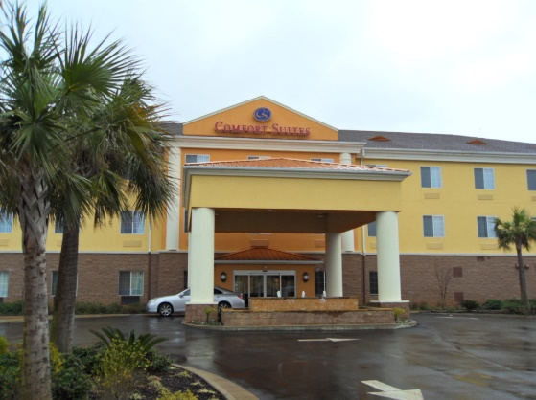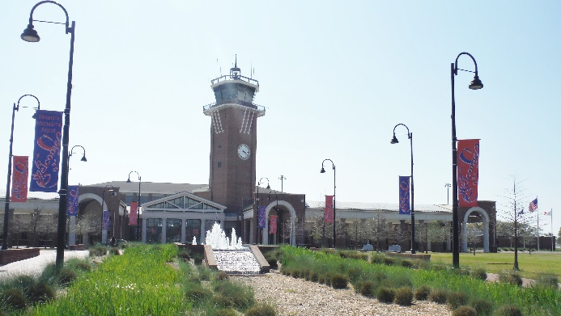

England AFB & 401st TFW Website: http://englandafb.com

****Saturday********
0700 – 0930 Breakfast - hotel breakfast room
1000 – 1100 Camp Beauregard Museum - tour and presentation
1200 – 1300 Picnic Lunch & Tour–Forts Randolph & Buhlow Park
Red River State Historic Park
1300 - 1400 Fort Board Room - talk and Q&A with James (Jim) T. Piner
_ EAFB Veteran, F100 Pilot, Misty Experiment, shot down Vietnam 14 July 1968
1600 - 1800 Happy Hour in Hotel Breakfast Room
1800 – 1930 Dinner – Poppa T’s Oyster House & Grill – Pineville, LA 71360
_ (10.1 Miles from hotel) 3306 Highway 28 E 318-445-0082
2000 - 2100 Hotel Breakfast Room – Dessert with Review of the day and debriefing
****Sunday*********
0900 – 1100 Breakfast - hotel breakfast room
1100 - ???? TBD

