Reunion 2022
England Air Force Base

401st/834th Supply Squadron

Who: 401st/834th Supply troops
and their guests

When: Friday April 8 - 10, 2022

Where: England Air Park
Airport 3rd Floor Conference Rm
1200----Until
Reservation Group Name:
401/834 Supply Squadron
Pizza will be served

Special Guest and Registration

Hospitality 1800—Until
Hotel Dining area

WE LOOK FORWARD TO SEEING YOU

****Saturday********
0700 – 1000 Breakfast - hotel breakfast room
1130 – 1300 Picnic Lunch –The Pavilion Buhlow Picnic Area
1400 – 1800 Hospitality – Hotel Dinning Area
1800 - ???? Dinner - Tunk’s Cypress Inn (Cash Bar)

****Sunday*********
0900 – 1100 Breakfast - hotel breakfast room
1100 - ???? TBD

Reunion Headquarters Saturday Evening
Comfort Suites Tunk’s Cypress Inn on beautiful Kincaid Lake

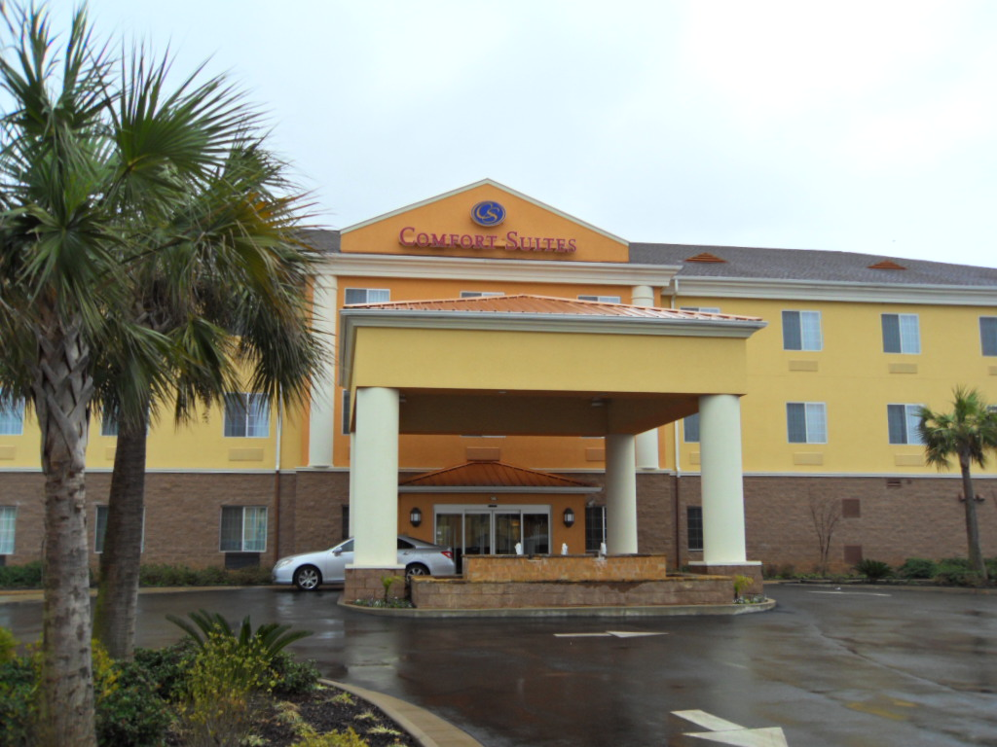

April 9, 2022
1800 hours
TUNK’s CYPRESS INN 9507 Highway 28
BOYCE, LOUISIANA 71409 (318) 487-4014

REUNION SOCIAL and DINNER

MENU

Louisiana Finest

FRIED CATFISH
OR
FRIED SHRIMP
French Fries & Hush Puppies
DINNER ROLL
SANDY’S BREAD PUDDING and
TEA

Cash Bar Open all night
BEER, WINE & SOFT DRINKS
available during Happy Hour (5PM ------>) and Dinner (6:00PM---->)

http://www.tunkscypressinn.com/

Tunk’s Cypress Inn is 10.2 miles from the hotel
Go through the base out the back gate to LA-28 and
drive West 6.1 miles to
Tunk’s on the South side just off LA-28

