Subject: District 3 Newsletter - Arapahoe Road CDOT Paving Project, ACSO Drug Drop Box, Food Trucks at Center Park and More!


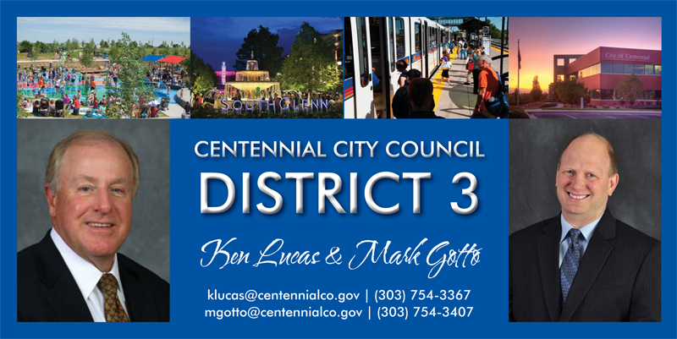

  In This Issue
  City Council Meeting
  Summer Event Schedule
  New Businesses
  CDOT Work on Arapahoe Road
  Sheriff's Office Launches Drug Drop Box Program
  Mobile Food Vendors at Center Park
  Out & About
  2nd Annual Business Appreciation Event
  City issues Request for Proposal (RFP) No. 14-06-02
  
  City of Centennial
  13133 E Arapahoe Rd
  Centennial, CO 80112
  www.CentennialCO.gov
  24/7 Citizen Response Center
  (303) 325-8000
  Report Issue Online
  Ken Lucas
  (303) 754-3367
  E-Mail
  Mark Gotto
  (303) 754-3407
  E-Mail
  Stay Connected
  
  Event Calendar
  
  City Council Meeting
  Monday, May 16
  6PM - Study Session
  7PM - Regular Meeting
  Centennial Civic Center
  13133 E Arapahoe Road (80112)
  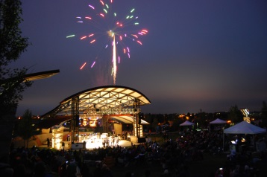
  Summer Event Schedule(more info)
  Friday Film Fest -
  Kung Fu Panda
  June 13, 2014
  7:00 p.m. - 10:00 p.m.
  Centennial Farmers & Artisans Market
  June 14, 2014
  10:00 a.m. - 4:00 p.m.
  Friday Film Fest -
  Back to the Future
  June 27, 2014
  7:00 p.m. - 10:00 p.m.
  Friday Film Fest -
  The Little Mermaid
  July 11, 2014
  7:00 p.m. - 10:00 p.m.
  Centennial Farmers & Artisans Market
  July 12, 2014
  10:00 a.m. - 4:00 p.m.
  Friday Film Fest -
  How To Train Your Dragon
  July 25, 2014
  7:00 p.m. - 10:00 p.m.
  Centennial Under the Stars
  August 9, 2014
  6:00 p.m. - 10:00 p.m.
  Centennial Farmers & Artisans Market
  August 9, 2014
  6:00 p.m. - 10:00 p.m.
  Recent Land Use Cases Approved by City Council
  April 14th
  Go Toyota FDP 4th Amendment
  J.D. Carpenter Facility, 9355 E. Dry Creek Rd. - Conditional Use
  Sonic Automotive FDP
  Vectra Bank FDP
  May 5th
  Top Golf Rezoning
  Learning Experience AIA Variance
  Learning Experience FDP
  May 19th
  Finn McCool's Rezoning
  South Denver Islamic Center Rezoning
  
  TopGolf
  City Council approved the TopGolf zoning in may and ratified the site plan in June. The company expects to break ground on the project later this summer.
  New Businesses
  35 Centennial-based entities registered a business or applied for a sales tax license in April.
  Helpful Links
  Council District Map
  Land Use Case Map
  Centennial Map Gallery
  South Suburban Parks & Rec
  Cherry Creek School District
  Littleton Public Schools
  District & HOA Resource
  Spring & Summer
  Summer Events
  Reserve Area at Centennial Center Park
  Public Works Current Construction Projects
  June 2014
  Thanks for taking the time to read our 4th installment of the District 3 newsletter. Your response to our content has been great. We appreciate so much your interest and passion in Centennial. Please continue to supply feedback. We are honored to be representing you to make Centennial the very best city it can be.
  This issue will supply you with important updates on street repairs to make your commute through the city as efficient as possible. There is a creative program through the Sheriff's department we will discuss. In the spirit of us trying to drive a business friendly city, the newsletter is packed full of new business information, business tours, and grand openings.
  Stay tune for our next announced District 3 meeting taking place in July. We have appreciated the turnout so much at the past two meetings. The agenda, location, and time will be sent out soon.
  Please feel free to forward this e-Newsletter to your friends in District 3.
  Ken & Mark
  CDOT Work on Arapahoe Road - Dayton to Jordan
  CDOT is scheduled to perform construction on Arapahoe Road in the coming weeks that will involve a mill and overlay of Arapahoe Road between I-25 and Parker Road, as well as intersection improvements at Dayton Street and Jordan Road. In preparation for this, the contractor will be conducting field investigations the week of June 2 that will require lane closures between 7 a.m. and 5 p.m. All planned lane closures are for acceleration/deceleration/ turn lanes; no closures to mainline Arapahoe are expected during the day, though some may occur from 7 p.m. to 5 a.m.
  We as your council members want to communicate to all citizens that this is a CDOT project and not a city project. However, we are working with city staff to ensure our citizens are aware of the construction and can take all precautions to move efficiently through the city. Even though we can't directly handle your complaints, we can channel any concerns through staff and send them to the CDOT contractors.
  Contact: Hamon Contractors (303) 419-4903
  Sheriff's Office Launches Drug Drop Box Program
  The Arapahoe County Sheriff's Office has launched a Drug Drop Box Program that allows the public to safely and anonymously dispose of unused prescription and non-prescription drugs.
  The Drug Drop Box is located in the lobby of the Sheriff's Office Headquarters Building, 13101 East Broncos Parkway, Centennial, CO. It will be available to the public year-round during normal business hours (Monday through Friday, from 7:00 a.m. to 6:00 p.m.), excluding holidays. (read more)
  Mobile Food Vendors at Center Park
  
  Starting Memorial Day weekend, the City will be havingmobile food vendors in the Centennial Center Park on a regular basis. The program allows for a total of four vendor at one time-two food carts Mobile Food Vendor webpage. Go to bottom of the page and click on vendor name to see menu.
  Interested in being a Mobile Food Vendor at Center Park?
  There are four vendor locations available-two within the park for food carts and two parking areas for food trucks. Cost for a monthly permit fee is only $10, with permits issued for specific sets of days (Mon/Wed/Sat, or Tues/Thur/Fri/Sun). Click here to get your application today! Applications and supporting documents must be submitted to parkinfo@centennialco.gov by the 15th of the previous month (i.e. applications for July are due by June 15th).
  Out & About
  Revitalized King Soopers Celebrates Opening
  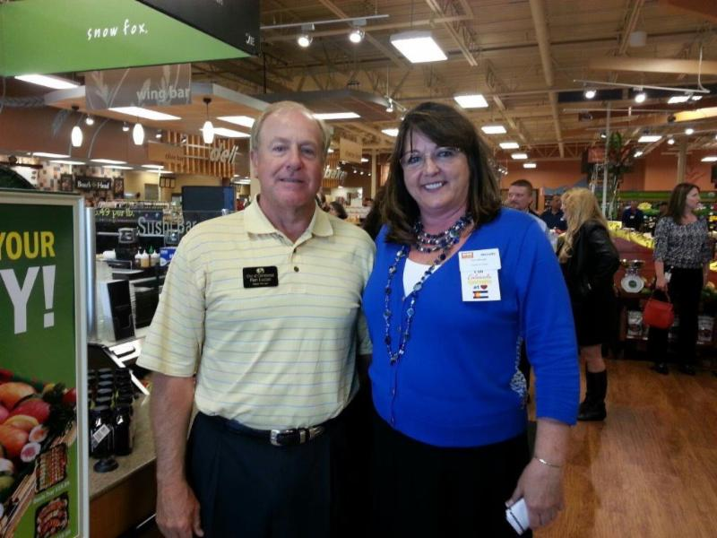
  Mayor Pro Tem Ken Lucas with King Sooper's store Manager Michelle Fallon at the grand reopening on May 21st of the newly renovated 16,000-square-foot Cherrywood Square shopping plaza. What a store! Great addition to the community. This newest expansion doubles the size which now includes a large deli and sushi bar. The sushi is great, stop in and try some!
  Celebrating the Comcast Xfinity Store Grand Opening
  
  Mayor Pro Tem Ken Lucas, with Mayor Noon and Council Member Kathy Turley, at the ribbon cutting of the new Xfinity store located at 8222 S. Yosemite Street, Centennial, CO 80112. If you are a Comcast customer you will love this store and its format. Stop in and take advantage of their offer to review your account to see if they can save you some money. You can return/exchange equipment, pay your bill, and see all the new offerings from Comcast.
  The Insider's Tour of AlloSource
  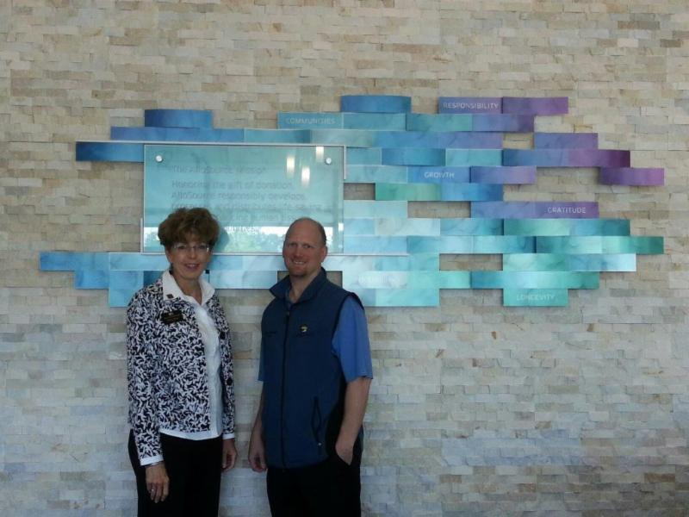
  The City Council toured a company located in Centennial that is making a difference in people's lives. The company's name is AlloSource. AlloSource is a nonprofit organization founded in 1994 to honor and respect the gift of human tissue donation by responsibly developing, processing and distributing life-saving and life-enhancing allografts for communities. They offer more than 200 types of precise bone, skin, soft-tissue and custom-machined allografts for use in an array of life-saving and life-enhancing medical procedures.
  As we toured the facilty we were amazed at the technology and innovation used to create products to help save and enhance lives. We saw the rooms ware various Grafts are created. We visited the Burn Care room where they create products to heal burns at a much higher rate. We concluded with the wound care department. It was truly an amazing experience. It made us proud we have such a company like this one in Centennial.
  I Scream, You Scream, We All Scream for Ice Cream!
  
  Join the City for the 2nd Annual Business Appreciation event July 9th from 2-4 PM at Center Park.
  But don't wait for your cold & tasty treat, it's National Frozen Yogurt month!
  City issues Request for Proposal (RFP) No. 14-06-02 for Fiber Optic Asset Inventory, Feasibility Study and Business Planning Services
  On June 2, the City issued Request for Proposal (RFP) No. 14-06-02 for Fiber Optic Asset Inventory, Feasibility Study and Business Planning Services through the Rocky Mountain E-Purchasing System.
  The City's pre-bid conference is tentatively scheduled for 1:00 P.M. on Thursday, June 26 in the Community Room at the Eagle Street Facility.

City of Centennial
13133 E Arapahoe Road, Centennial CO 80112
www.CentennialCO.gov
Call (303) 325-8000 to reach our 24/7 Citizen Response Center

Copyright © 20XX. All Rights Reserved.

