
Shake off those Winter Doldrums and
Celebrate Spring with your Neighbors!

At Nonna’s Italian Bistro ~ 11877 E. Arapahoe Rd.
Enjoy a Happy Hour on Tuesday, March 24
5:30 – 7:30
Appetizers are provided and drinks are on you.
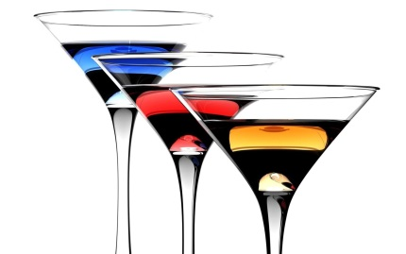
RSVP to Lou Palley by Friday March 20
(303) 770 – 8035 / Lpalley@hotmail.com

