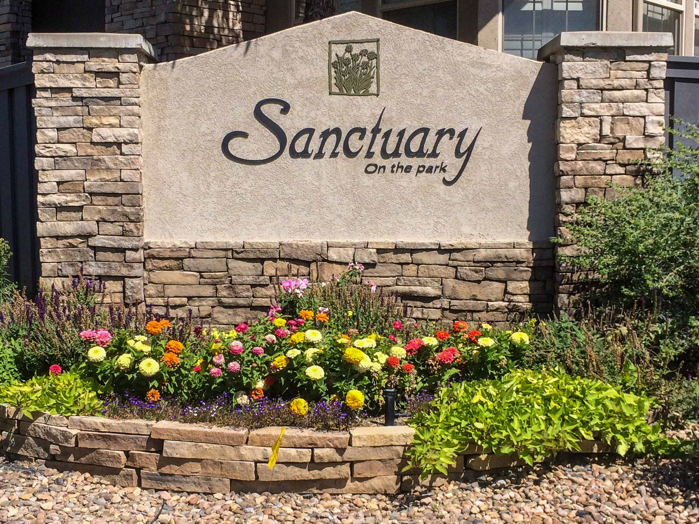
“From the Board - - - “

News from your Sanctuary on the Park Board, April 2016

Annual HOA meeting

The annual meeting was held on January 20th, 2016 at Valley Country Club. Muriel Leff announced that we will use the same contractors for 2016, including our management company (BRC), with landscaping and snow removal by Summit Services, and tree care with A Climb Above Tree Company, and The Big Ash Tree (for tree bugs.)

Dale Jensen discussed the 2015 financials, and explained the budget for 2016. He noted that monthly dues had not increased for several years. But with increased expenses, especially for control of weeds and tree bugs, the Board recommended an increase to $200, starting in February. Homeowners approved the budget including the increase in dues.

Board and Committee membership: Muriel Leff announced that she had completed her term and would not run for re-election. Stan Massey also announced his retirement from Chairman of the Grounds Committee, and Lou Palley has resigned from Chairing the Social Committee. Homeowners thanked them all for their long and conscientious service.

Earl Wenngren had submitted an application for the vacant position, and was duly elected and welcomed to the Board.

At the Quarterly Board meeting on February 25th the new officers were elected, with Geoff Lane becoming President, Dale Jensen remaining Treasurer, and Earl Wenngren was elected Vice President.

Landscaping 2016

The swallows are back, and the plants and weeds and trees are showing new growth! And in Spring, we can expect the usual alternating showers, sunshine, and even snow – fortunately not quite as bad as last year’s Mothers’ day storm!

This year, Carol Race is the Chair of the Grounds Committee. This is a very busy committee, and some responsibilities will be directed by members with expertise in those areas. With the arrival of Spring, the committee will be meeting monthly. The meetings will be open to all residents, for questions and answers. The next meeting will be on April 25th at 4:00 p.m. in Carol Race’s home

We thank Stan Massey for his many years of service as Chair of this vital and busy committee! He has kindly agreed to to stay on the committee, with responsibility for the common area irrigation system. Geoff Lane will provide experience with control of the tree bugs, and Kathy Childs will be developing plans for long term landscaping and plantings.

Garden Club

If there is sufficient interest in a Garden Club, the Grounds Committee would like to sponsor a group of interested gardeners. The group would operate separately from the HOA, and similarly to the Bird Watchers. If you are curious about plants and what grows well in our area as well as what keeps rabbits at bay, please indicate your interest by calling Carol Race (303-400-3451) or Kathy Childs (303 – 809-4963).

Spring activation of irrigation systems

Our other ‘Rite of Spring’ is the activation of our homeowner sprinkler systems! This year, Summit Services plan to activate our systems on Tuesday, May 3rd, from 8 am through 5 pm. Those who are able should follow the instructions to turn the valve on inside your house; full details and instructions will be sent out in a few days. (The outside backflow has been prepared for the activation.) If you need help to find or open your shut off valve, you will be asked to call Summit Services.

Weed Control
- The Board included funds for weed control in the 2016 budget, and treatment will be done in the Spring at a favorable time.

Tree Bugs

- Emerald Ash Borer (EAB)
- Was first detected in the Boulder area in September 2013, but was probably present in that area for several years previously. This bug kills ash trees very quickly, and typically spreads about ½ mile every year. Boulder has about 98,000 ash trees at risk of infection! Boulder is now a quarantined area, with restrictions on the movement of dead wood etc, since human activity can help spread the disease quickly and much further.
- The disease has yet to be detected in the Denver area, though it will likely arrive within a year or so. Since our developer planted an ash tree in most front yards (yes, there also ash trees in another 2 back yards) they are a major feature of our landscaping.
- Most damage to ash trees in Colorado is caused by environmental factors (freeze, drought etc.) and pests other than EAB, including lilac ash borer, ash bark beetle and others.
- Pine tree beetles.
- We have about 130 pine trees, – mostly Ponderosa (43) and Austrian (86) pines. There are approximately 95 pine trees in the Common Area; the remainder are in homeowners’ yards.
- We discovered a variety of pine tree infestations last year, affecting about 1/3 of our trees. Pests included the Zimmerman Moth, Mountain Pine beetles, and Red Turpentine Beetles, and possibly some Ips beetles. Several arborists inspected some or all of the trees, with wide variation in the types of bugs identified and estimated cost for remedial treatments.
- The Board selected the Big Ash Tree company to administer a systemic spray to all unprotected pine trees last year, and again this year
- Tree protection in 2016
- This year, we have approved a single systemic treatment for the ash and pine trees with “Transtect-70” (dinotefuran.) It is sprayed on the tree trunks from ground level and up 4½ ft., and is absorbed through the trunk.
- This seems much more friendly for the environment than spraying the whole trees, which can harm birds and other wildlife, and would require 2 treatments annually. The price seems favorable when compared with the range of prices that individual homeowners have experienced.
- There are some fine Colorado blue spruce trees in the community. When inspected last year they were healthy and disease free. But with advance of spruce beetle infections, and possible Ips beetles, we are considering treating these trees also.
- All susceptible trees should be treated, to prevent (untreated) infected trees from re-infecting those we treat.
- The treatment should be applied sometime in mid-May, depending on the weather and when the ash trees develop leaves and flowers.

Fire Mitigation.

Our landscaping company (Summit Services) will continue mowing grass and weeds along designated tracts for about 30 ft from the homeowners’ houses as agreed last year.

Asphalt and concrete repairs

We are planning on some routine repairs to the roads including patch repairs, crack sealing, and replacing some broken concrete swales. We will let you know when this is scheduled, and some of us with damage to parts of our driveways may wish to use the same company if they can offer suitable rates etc.

New Neighbors

We welcome Van and Diane Horsley, who have moved to 6157 S Carson. They enjoy golf, and already know the Races and the Ploens from VCC.

Upcoming events

The Social Committee is planning the next function for early summer, and encourages you to respond to their recent survey if you have not already done so.

The Committee is looking for a volunteer to host the “Oktoberfest;” easy access to a backyard through a walk out basement would be ideal. They also need a volunteer to host the annual “Cup of Cheer” next December – please let them know if you might be able to help with either event!

Miscellaneous

Reconstruction of the I25 Bridge over Arapahoe road and interchange is scheduled to start in May, with completion expected in the summer, 2018. There will be some nighttime closures of Arapahoe Rd as they replace the bridge (in 3 phases.) Those who use that exit may wish to consider alternate routes!!!

You can get more information from the project web site www.codot.gov/projects.co.us and you can sign up for email updates.

Geoff Lane, President
Earl Wenngren, Vice President
Dale Jensen, Treasurer
April 17, 2016

GL:417

