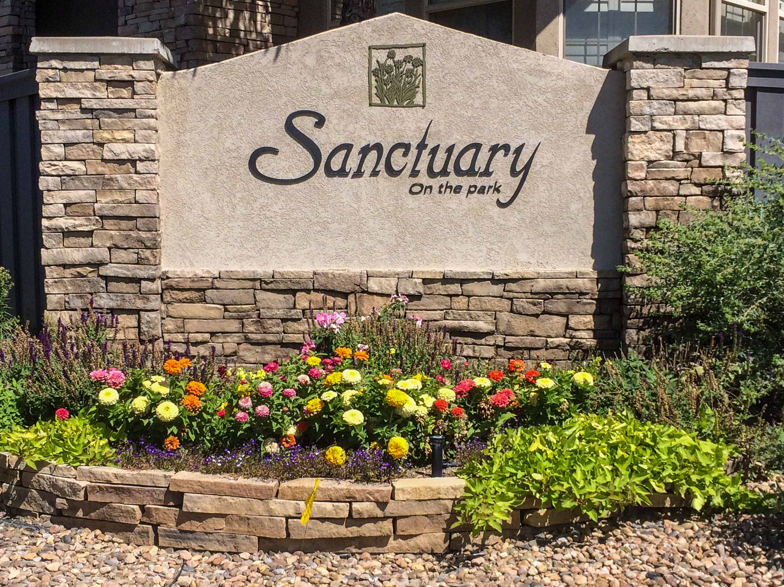
“From the Board - - - “

News from your Sanctuary on the Park Board, September 2016

In this issue:
- Changes at BRC
- Weeds and bugs
- Street repairs soon
- Cherry Creek Dam
- Social events, new neighbors

Changes at our management company. BRC

We welcome Cathy Baker, our new manager at BRC. Cathy brings 4 years of experience in the HOA industry, where she started on the accounting and financial side. She has her CAM license from the State of Colorado, and we look forward to working with her. Cathy can be contacted at BRC:

Cathy Baker
COMMUNITY MANAGER
9331 Commerce Center Street | Suite A1
O: 303.804.9800 | D: 303.541.1586
cbaker@brcrealestate.com www.brchoa.co

Landscaping 2016: Weeds and Bugs!

Weeds

The wet spring encouraged some weeds to grow, though less then last year.

We thank the volunteers who helped on the “Cleanup Day,” for some of the improvement. They concentrated on trimming thistles and the tall ‘common mullein’ that is especially conspicuous with its’ tall dark brown stalks that develop once the yellow flowers have gone. Though susceptible to the weed control chemicals, it helps if we hand trim and bag the stalks before the seeds disperse!

We contracted to have chemical controls sprayed over the common areas, which look much better than they did last year. The field to the north east of the community was slow to respond, and a second application was done (without further cost,) and it is looking better now.

Summit Services continues to apply weed controls to our lawns, despite the hot weather, which can make the chemicals less effective.

Tree Bugs

The ash, pine and spruce trees were all sprayed to prevent the various beetle and boring insects that can infect them. The treatment is absorbed through the bark into the trunk of the trees, and should last about 12 months.

Some of the pine trees still show some small round masses of pitch where the Zimmerman Moths attacked them. This can look like a collection of golf balls on the upper side of the branches, in the angle adjacent to the trunk. The pitch does not necessarily indicate a current infection, but persists and takes time to go away.

Emerald Ash Borer (EAB) has spread from Boulder to Longmont, but has not been detected in Denver yet. Most of the damage to ash trees in the Denver area comes from the various other pests, including lilac borers.

Bees

We noted in April’s newsletter that a bee colony had inhabited the monument at Caley and Jordan, in the brick column to the left of the “Sanctuary” sign. Though the cavity was plugged with steel wool, some worker bees continued to crawl back in, and the population grew rapidly. The pest control company returned and removed another colony. They applied mortar under the cap of the brick column, and that has successfully prevented further colonization.

Sprinklers

Our irrigation systems, both in the common areas and in our own yards, are showing signs of aging and have needed many repairs this season. The HOA does provide for repairs in both our yards and in the common areas, but does not pay for extending our irrigation systems for new landscaping etc.

The cost of the water to irrigate the common areas is a major expense, and was higher than usual for several months. Most of the excess was probably from damage to a lateral line that wasted a lot of water before it was detected. Please let us know if you notice leaks from the common area systems. They are usually scheduled to operate early in the morning, so our “early birds” are most likely to see problems as they walk or run around the neighborhood. If you have a problem with your sprinklers, or see a leak in the common areas, please let Cathy know at BRC. There is a “hotline” for irrigation and snow emergencies at Summit Services, (303) 591-3918

Landscape Improvements

Kathy Childs has been responsible for coordinating our long-term landscape projects.
There are funds in the reserve account specifically for landscape improvements and plantings. While consulting the long-term plans that were purchased by a previous board, the grounds committee has been prioritizing what needs to be done to improve the overall appearances. This year, most of the efforts have been with the 3 entrances to the community, which are all showing significant improvement.

We thank Kathy for all her hard work, along with members of the garden club who have helped her with watering and trimming plants.

Tree Rings

We had a complaint that the mowers bumped into a tree, causing some minor damage to the trunk. Our landscape contractor recommends creating “tree rings” around the base of the trees with ‘Roundup’ to minimize any damage to the trees. Many homeowners already have grass free rings around their trees, some lined with decorative brickwork. Tree rings can be created by applying a little Roundup, to create a grass free zone about 8 inches around the base of the tree. He assures us that the trees are not damaged or affected by the round up.

The grounds committee and board have discussed this with representative owners, and the consensus is that the HOA does not want to use Roundup as a general principle. Individual owners are encouraged to consider creating tree rings, though during a routine inspection we did not observe any damage to tree trunks, and the landscaping company appear to be doing good work.

Other mowing issues!

The landscaping company is developing a schedule for mowing those areas that do not require weekly mowing, so they continue to get attention on a regular basis.

Asphalt and concrete repairs

We are planning on some routine repairs to the roads including patch repairs, crack sealing, and replacing some broken concrete swales. This should occur at the end of September or early October.

The contractor will be here before the next board meeting on Wednesday, September 14th. Homeowners who would like to discuss having repairs to the concrete in their driveways while the equipment is here should meet with him at 5:45pm by the mailbox on S Blackhawk.

Cherry Creek Dam Safety Modification Study

(Stan Massey has been following the dam modification discussions, and we thank him for providing information about some upcoming public meetings.)

The Corps of Engineers consider Cherry Creek Dam to be one of their ‘high-risk’ structures because of the potential loss of life downstream should it ever fail. The dam is an earthen embankment. If water rose and overtopped it, the dam would soon fail as water running down the north side eroded the soil.

Rainfall that could fill the dam to the top is extremely unlikely, though as recent storms elsewhere have shown, floods can occur. It would require extreme storms capable of delivering 27 inches of rain over 3 days to bring water to the top of the dam!

The normal surface elevation of water in the reservoir is 5,550 ft. The last heavy storms on 9/14/2013 raised the surface elevation just 3 ft. to 5,553.4 ft., and the highest level ever reached was 5,567ft in1973. That leaves a lot of storage before water would start flowing through the spillway (at 5,610.6 ft.) while the top of the dam is at 5,664 ft.

The Corps appears to favor a change in the operating rules, to be able increase the releases from 5,000 cfs to 13,300 cfs, when extreme rainfall occurs. Cherry Creek dam is operated together with Chatfield and Bear Creek reservoirs to protect downtown Denver.

If you are interested in learning more, there are several open meetings scheduled in September:

Tuesday, September 20, 2016 from 6:00 - 8:00 p.m.
Cherry Creek Presbyterian Church
Rooms 112/113 (Main Building)
10150 E. Belleview Avenue
Englewood, CO 80111

. Wednesday, September 21, 2016 from 5:30 - 7:30 p.m.
Virginia Village Library
1500 S. Dahlia Street
Denver, CO 80222

. Thursday, September 22, 2016 from 5:30 - 7:30 p.m.
Aurora Municipal Center
City Café
15151 E. Alameda Parkway
Aurora, CO 80012
For more information, see http://www.nwo.usace.army.mil/Missions/Civil-Works/Planning/Planning-Projects/Cherry-Creek-DSMS/

Safety and Security

Some clothes and other belongings were stolen from a car parked on a driveway overnight. The vehicle was probably unlocked, as the alarm did not go off.

Please be careful and lock your cars overnight if they are not inside the garage!

New Neighbors

We welcome several new neighbors to our community, please introduce yourselves, and encourage them to attend the upcoming Oktoberfest!

Jerry and Cindy Adamek have moved to 6211 S Blackhawk Ct, from SE Denver.

Frank and Betsy Thornton have just moved into 14142 East Maplewood, from South Denver

Jim Petre has moved into 6260 S Carson.

Social events

The social committee is organizing an Oktoberfest celebration for Wednesday, September 21st at 5:00pm at 6222 S Blackhawk Ct. The “Cup ‘O Cheer” is scheduled for Sunday, December 4th. Further details about these events will be sent out soon.

Miscellaneous

The I25 bridge over Arapahoe Road construction continues; you can get more information from the project web site https://www.codot.gov/projects/I25-Arapahoe and you can sign up for email updates.

Geoff Lane, President
Earl Wenngren, Vice President
Dale Jensen, Treasurer
September 6th, 2016

GL: 906a

